EUIPO User Group meeting: Strategic session

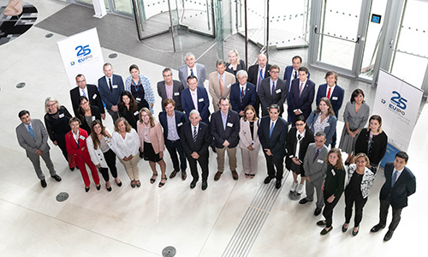

The EUIPO hosted a User Group meeting on 13 September 2019.  
  
The meeting brought together 20 representatives from 14 international user associations. The purpose of this Users’ Group was to bring together the User Associations to exchange views on the **draft Strategic Plan 2025 and the proposals for the new European Cooperation Project definitions.**  
  
The Executive Director, Christian Archambeau, opened the meeting by giving first-hand information on the [consultation process](https://euipo.europa.eu/ohimportal/en/news/-/action/view/5199236) of the Strategic Plan 2025. Participants were invited to share their views in an interactive session.  
  
The participating User Associations also provided feedback on the future European Cooperation Projects, which promote convergence of practices and tools in a variety of areas of activity and are closely linked to the Strategic Plan.  
  
The feedback and contributions obtained will be taken into consideration for the final draft plan, which will be submitted for approval of the EUIPO’s Management Board in November 2019.  
  
The [User Group](https://euipo.europa.eu/ohimportal/en/our-partners) is an official forum in which representatives gather to exchange views on EUIPO’s strategic activities and projects, in particular those activities **with a direct** **impact on users**.